By Sri Pranathi Challagolla

**Code Converters:**

* Code converters are combinational circuits that change data from one binary code to another.
* They are used for compatibility between systems, error reduction, and display purposes.
* Common types: Binary–Gray, Gray–Binary, Binary–BCD, BCD–Binary, BCD–Excess-3,

Excess-3–BCD.

**1.Binary to BCD code conversion:**

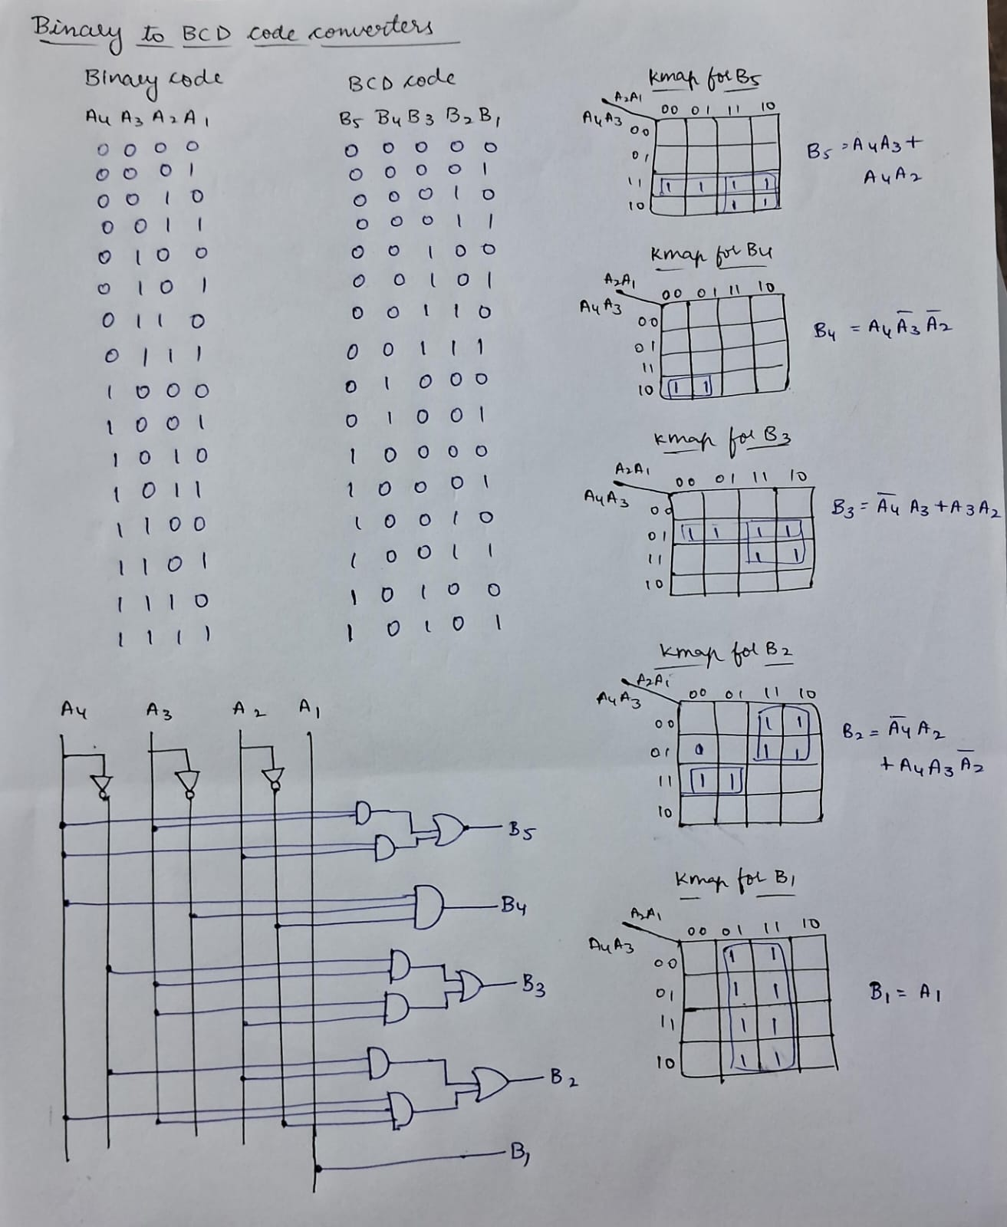

**Implemented Binary to BCD code converter:**

**Design:**

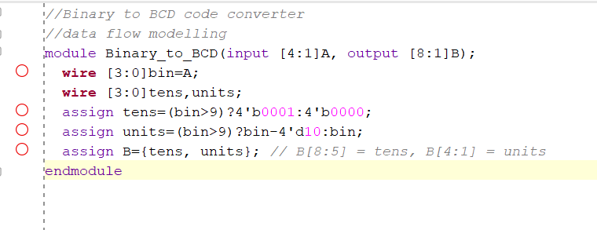

**Testbench:**

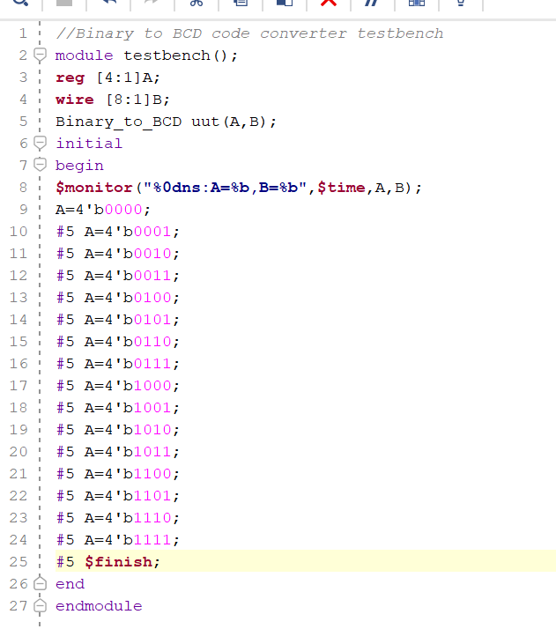 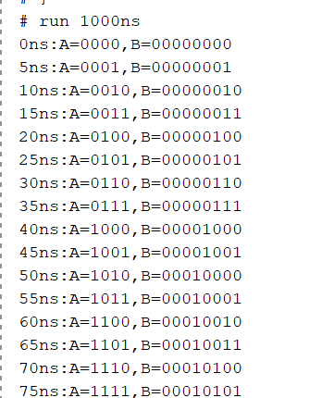

**2.BCD to Binary code conversion:**

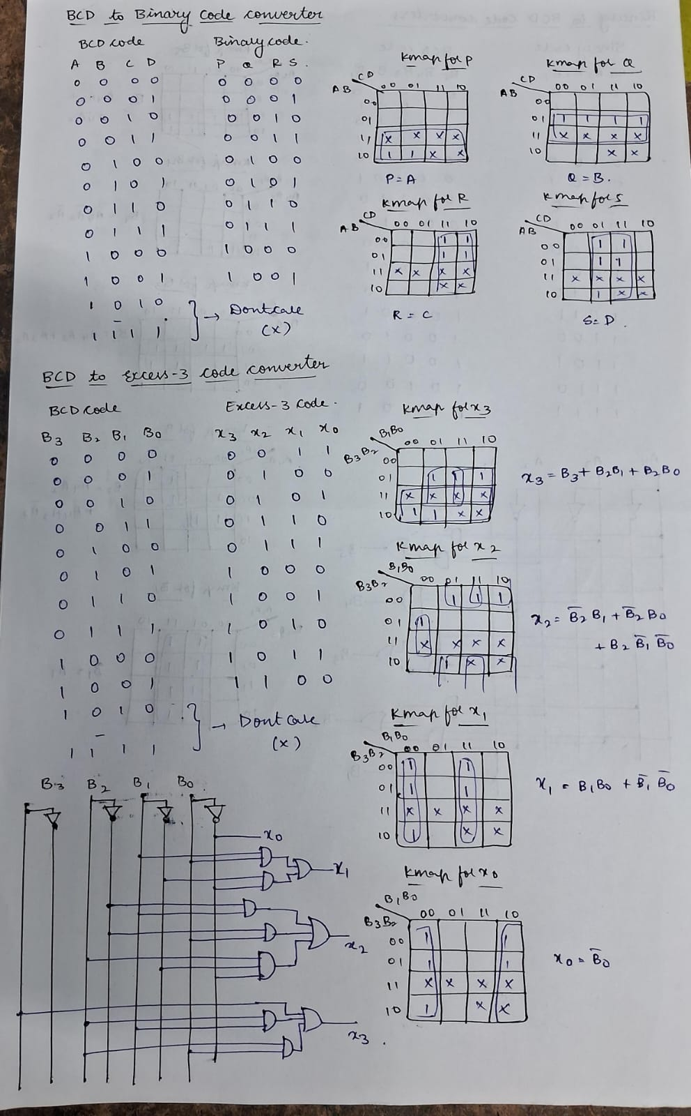

**Implemented BCD to Binary code converter:**

**Design:**

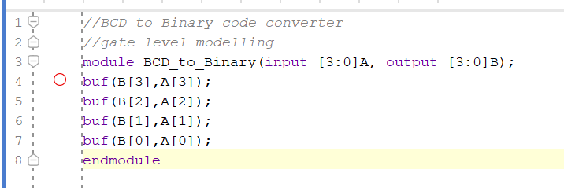

**Testbench:**

**3.BCD to Excess3 code conversion:**



**Implemented BCD to Excess3 code converter:**

**Design:**

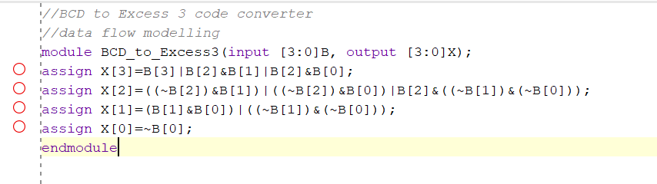

**Testbench:**

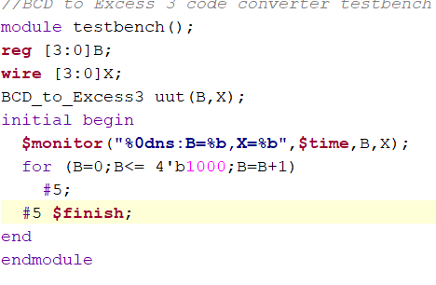

**4. Excess3 to BCD code conversion:**

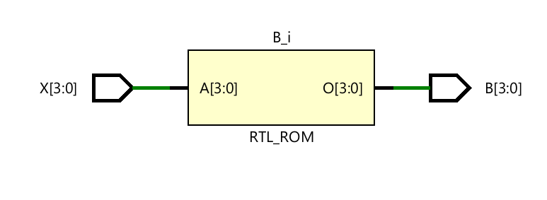

**Implemented Excess3 to BCD code converter:**

**Design:**

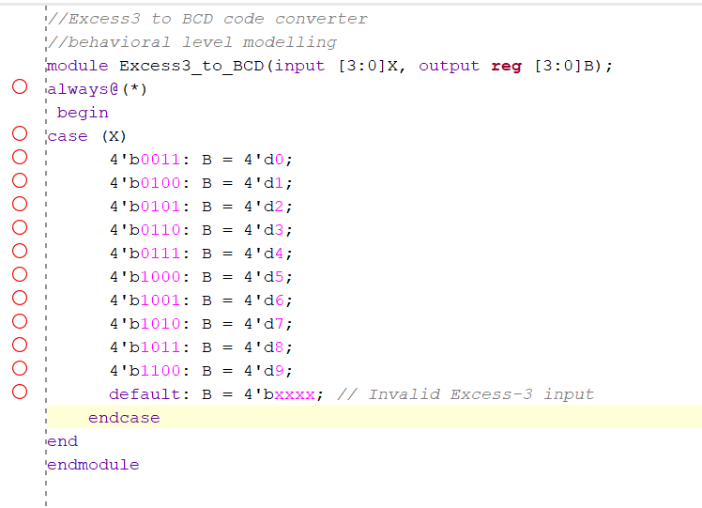

**Testbench:**

